EDULOG’S PARENT PORTAL LITE APP

FREQUENTLY ASKED QUESTIONS FOR PARENTS AND CAREGIVERS

GENERAL

Q: What is Edulog’s Parent Portal Lite? How do I sign up to use it?
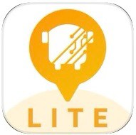
A: The Parent Portal Lite mobile app by Education Logistics, Inc. (Edulog) allows school districts to share school bus locations with parents and caregivers. The app can show the position of the school bus and give an alert as the bus enters a notification zone.

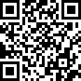
Download the Edulog Parent Portal Lite from the Google Play Store or the Apple App Store. Just point your smart phone cam- era at the QR code and it will take you right there!
Alternatively, search for “Edulog Parent Portal Lite” and choose the app with the yellow icon - it says “LITE” at the bottom.

NOTE: Edulog’s standard Parent Portal app uses a logo with a WHITE bus on a TEAL background, so take care to download the correct app. You want LITE.

Once you download the app, register using your email address. You must confirm registration via the email you will receive from support@edulog.cloud. If you do not receive the confirmation email right away, check your spam or junk mail folder.

Q: Is there a Spanish version?
A: Yes. Once you have the app installed, the language can be changed from English to Spanish on the SETTINGS tab. Make sure to select SAVE to continue in the language of your choice.

USING THE APP

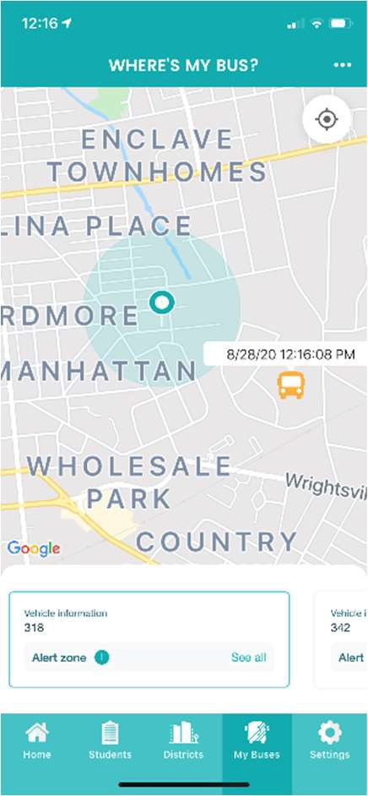
Q: How do I follow a bus in the Parent Portal Lite App?
A: In order to get started, you must receive a registration code from your school district. This code is specific to one or more buses in the district. Go to the DISTRICTS tab, tap the plus sign (+) in the top right to add your district code. When the code is accepted, you will see the name of your district and the number of buses (initially zero) that you are following. You might need to add another registration code for the same district to follow more than one bus for your family. This depends on your district’s app configura- tion.

Q: How do I choose buses to follow in the app?
A: Tapping your district’s name on the DISTRICTS tab shows the list of buses that your code authorizes you to follow. Sliding the toggle to the right allows a bus to be moved to the MY BUSES tab. On the MY BUSES tab, you will see the list of buses that you selected.

Q: How do I see the bus location in the app?
A: The location of a bus can be viewed by tapping that particular bus at the bottom of the MY BUSES tab. Swipe to see additional buses.

9/04/20 Smarter Transportation.

Edulog’s Parent Portal App Frequently Asked Questions for Parents and Caregivers

Q: What does the date and time stamp mean on the map?
A: The last reported time for the school bus is displayed beside the bus icon. NOTE: App users should understand if the bus location has not been reported for a while, there could be problems with the GPS signal or other communications issues. Students should report to their bus stop at the usual time, 5 minutes before the expected arrival of the bus. The time display is important information to help parents correctly interpret the Where’s My Bus information.

Q: What does the HOME tab tell me?
A: The HOME tab shows the list of vehicles that you have selected, along with the registration code and the number of notification zones that are active for each.

Q: Why can’t I see the location of our school bus at night or on the weekend?
A: The school district has the option of when to allow the bus icon to be visible on the map. Many districts opt to show the bus icon only when buses are running routes.

Q: What if the map is inaccurate?
A: Edulog’s parent app uses Google Maps as its base map for display. No map source is perfect, but we have found the data in Google Maps to be sufficiently accurate to support the app. Unfor- tunately, Edulog has no ability to immediately correct Google’s base map. You may provide infor- mation directly to Google Maps via their “send feedback” option at
https://www.google.com/maps.

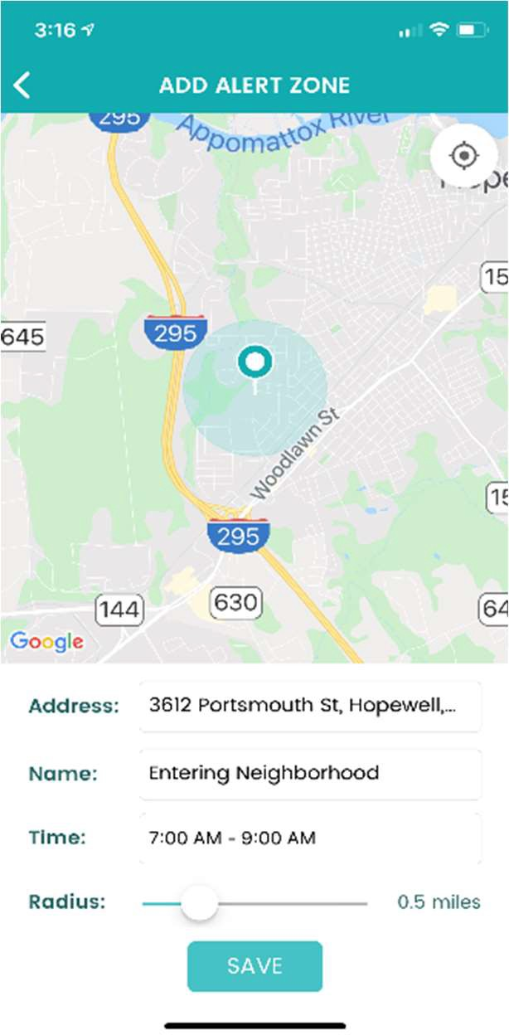
RECEIVING NOTIFICATIONS

Q: How reliable are the notifications?
A: The notifications are sent immediately when a GPS ping from your bus occurs within the notification zone. The school bus sends regular GPS pings to the app database in the cloud every 10-20 seconds. As with all technology, disruptions can occur. A lag can be produced if there is a disruption in cellular service or the GPS unit on the bus is disconnected. Make sure to monitor the app for bus movement prior to the expected time of the bus.

Q: How can I be notified when my bus enters a certain area?
A: Setting alert zones in the app allows you to receive notifications when the bus enters one or more zones that you define. Choose an address as the center of the notification zone (enter the address or move the map graphically) and a radius from 0.1 to 2.0 miles. Alert zones are created on your mobile device, specific to each bus.

Q: When will I get notifications in the radius around my student’s bus stop?
A: You can receive notifications when the bus enters any of your alert zones. In addition to designating the distance of the radius, you can also designate a time window in which you want to receive notifica- tions. For instance, if the bus runs a field trip and enters your alert zone in the evening, you probably do not want to receive that alert. Set
each time window to make the most sense for each bus route. If you want to receive notifications in the morning and in the afternoon, you will need to have a time window covering the entire day, or create one alert zone for the morning and another alert zone for the afternoon.

9/04/20 Page 2

